EN.520.680 HW3

1. According to the question, set the fs = 130hz. Then, simulate the three phoneme /aa/, /uh/, /iy/ from the spectral peaks it gives. They are in the work generator.m and I also save the analysis graph below:

/aa/:

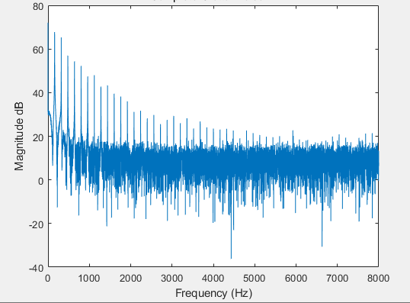

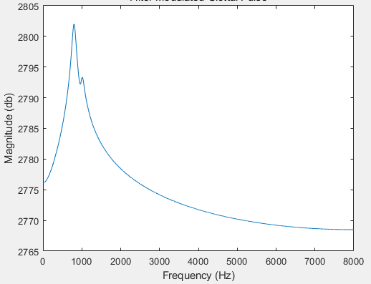

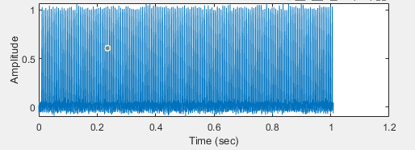

/uh/: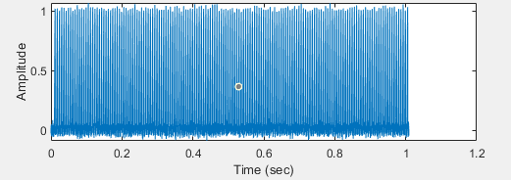

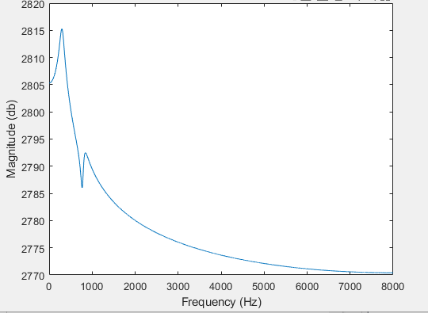

/iy/: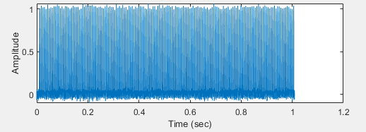

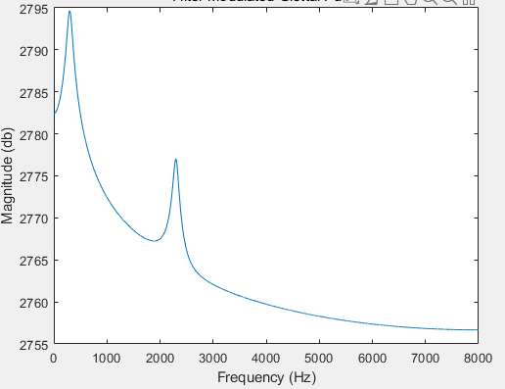

1. Then I listened to the resulting sounds, all bi-sounds similar to the original signal. But if you listen carefully, you can still hear the difference in vowel pronunciation. The sound of the original signal can be roughly heard as the vowel sound, which is enough to show that the most important identification of the sound is the combination and difference between the pitches. Just like our vocal tract takes different shapes to imply different frequency responses of the vocal tract. The Similar shapes of the vocal tract will have similar spectral envelopes. The more different spectral envelopes make more different vowels you will be heard.
2. Construct a new F with the formula F_i = F_i_base - alpha * cos(pi * distance/length * (2i-1)) * (c/4l) * (2i-1), check the length of the speech in question1 and construct the resonators from this to simulate waveforms. Set the constrictions at the spectral peak in the phoneme.